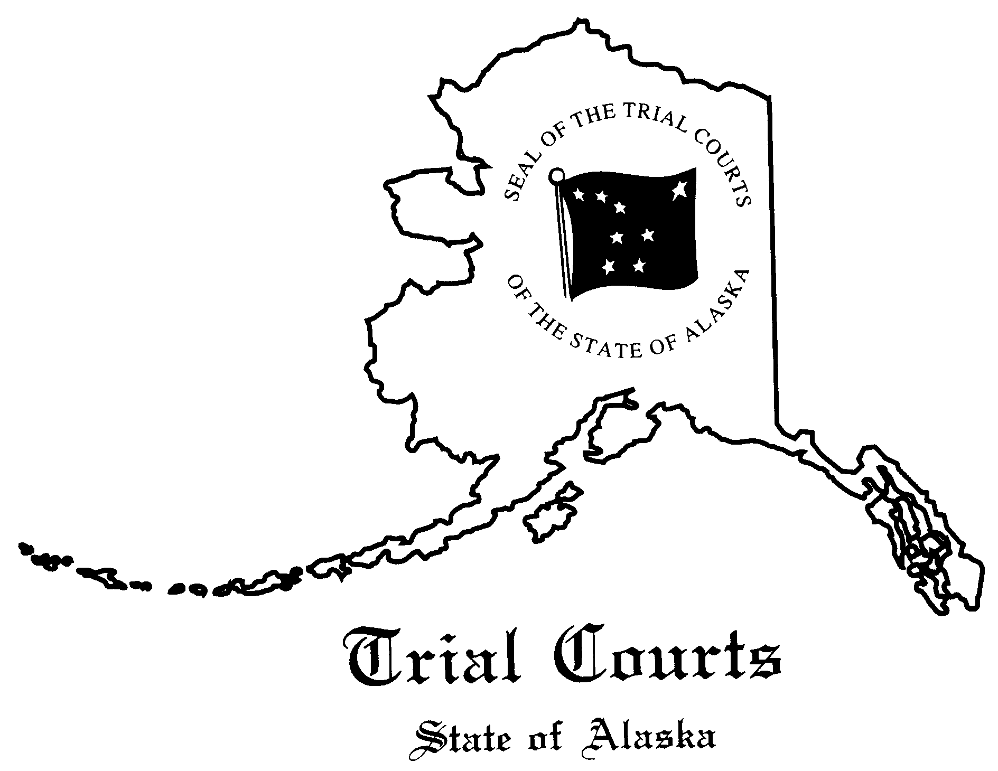

NOTICE TO ATTORNEYS AND MEMBERS OF THE PUBLIC

THE ANCHORAGE DISTRICT COURT ADHERES TO THE FOLLOWING GENERAL RULES OF COURTROOM CONDUCT

- Be on time.

- If unavoidably delayed, contact the in-court clerk’s office at 264-0709 to advise the court about the delay.

- Be appropriately dressed and groomed.

- Business attire for attorneys, conservative dress for litigants.
- Remove hats prior to entering the courtroom.

- Be quiet.

- Mute cell phones, pagers and other electronic devices.
- Keep communication and noise minimal - leave the courtroom for conversation.
- Infants and toddlers should not be brought to court. If a child is present, he or she must be quiet while court is in session.

- Be respectful.

- Stand when the judge or jury enters or leaves the courtroom.
- Stand when addressing the court; ask for permission to remain seated if necessary.
- Ask for permission before approaching the bench or the witness stand.
- Do not address parties, counsel, witnesses, or others by their first names.
- Do not argue with the court.
- No food or beverage is allowed in any courtroom. Water is provided.

